%To detect Face

FDetect = vision.CascadeObjectDetector;

%Read the input image

I = imread('james.jpg');

%Returns Bounding Box values based on number of objects

BB = step(FDetect,I);

figure(1),

imshow(I); hold on

for i = 1:size(BB,1)

rectangle('Position',BB(i,:),'LineWidth',5,'LineStyle','-','EdgeColor','r');

end

title('Face Detection');

hold off;

Results Obtained:

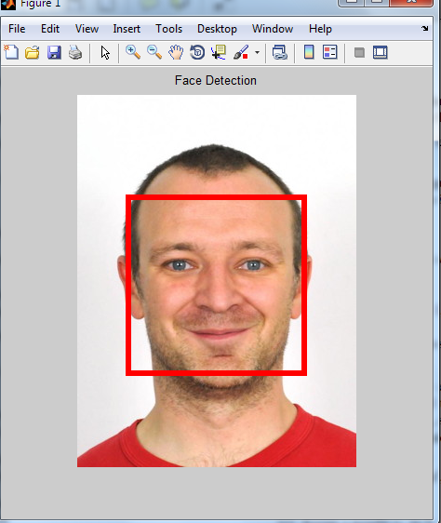

%To detect Eyes

EyeDetect = vision.CascadeObjectDetector('EyePairBig');

%Read the input Image

I = imread('james.jpg');

BB=step(EyeDetect,I);

figure(3),imshow(I);

rectangle('Position',BB,'LineWidth',4,'LineStyle','-','EdgeColor','b');

title('Eyes Detection');

Eyes=imcrp(I,BB);

figure,imshow(Eyes);

Result obtained:

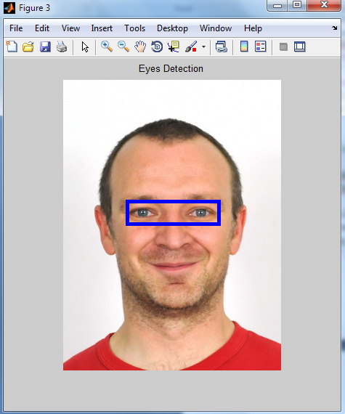

%To detect Nose

NoseDetect = vision.CascadeObjectDetector('Nose','MergeThreshold',16);

BB=step(NoseDetect,I);

figure(2),

imshow(I); hold on

for i = 1:size(BB,1)

rectangle('Position',BB(i,:),'LineWidth',4,'LineStyle','-','EdgeColor','b');

end

title('Nose Detection');

hold off;

Result obtained:

